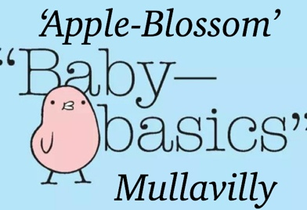
REFERRAL
FORM
Date: _______

Contact Details:
Caroline Whitten
Elizabeth Cairns
Mobile: 07856885737
Email: mullavillybabybasics@gmail.com

Use this Referral Form as a Template to submit your referral by email or telephone and we will contact you to confirm details. If possible please leave a contact number for us to ring you. (Please do not leave information via Private Message on Facebook Messenger, this is used for information and publicity only)

Request Details
Request made by:
Agency/Church/Charity etc:
Office phone number:
Mobile phone number:
Email address:
Preferred Completion date (please leave 4-5 working days)
If Urgent – please indicate

Client Details
Name of Client:
(first name only or initials are fine)
Due Date: (or age of baby if born)
Baby gender: (if known)
Is mum breastfeeding or planning to? (if known)
Any siblings? (if known)
(some clothing comes with best sister or little brother etc & may not be app.)

Please indicate Item Requested | Needed
Moses basket starter pack
Moses basket (empty)
Starter pack - No basket / No bath
Baby Bath starter pack
Baby Bath (empty)
Clothing bundle (for other siblings in family-include sizes)
Other

Starter pack includes: (there may be slight variations depending on items available)
For Mum | For Baby
Maternity pads / Breast Pads / Sanitary towels | New born nappies/Nappy Bags
Toothbrush / Toothpaste | Baby Shampoo / Wash / Lotion
Shampoo / Shower Gel / Deodorant | Sponges/flannels
Hand soap / hand Cream | Nappy bags/Wipes
Blanket / Sheet | Bibs
Moses Basket & NEW Mattress or Baby Bath | Baby Towel / Baby Grow
Soft Toy | Vests / Cardigan / Hat / Mittens / Socks

